Mrs. Ratz [lratz@mcpsmt.org](mailto:lratz@mcpsmt.org)

Chemistry I Course Overview

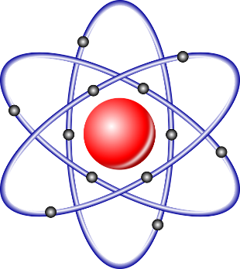Chemistry 1 topics are selected to cover main chemistry concepts and develop and reinforce problem-solving skills. Students will work throughout the year on a combination of lab exercises, written assignments, demonstrations and lecture note-taking. This class is open to all students in grades 10-12 who have completed Earth Science and Biology.

Quarter 1

General chemistry background and atomic structure

Intro to lab safety, lab procedures and equipment, intro to periodicity, organization of data, logic problems, lab unknowns, properties of elements, chemical families, atomic models, nomenclature, and history of chemistry.

Quarter 2

Compounds and Equilibrium

Testing and grouping of compounds; organic and inorganic acids, bases, salts, ionization, neutralization, concentrations, balancing equations, equilibrium, pH, hydrolysis of a salt, LeChatelier’s principles and oxides.

Quarter 3

Oxidation-Reduction (REDOX)

Activity of metals and metal ions, corrosion, anode and cathode reactions, two metal corrosion, oxidation numbers, balancing redox equations, activity of nonmetals and nonmetal ions.

Quarter 4

Qualitative Analysis

A four-week unit entirely devoted to identifying chemical unknowns in the laboratory.

Organic Chemistry (carbon compounds)

Hydrocarbons, functional groups, carbohydrates, polymers, structure and nomenclature.